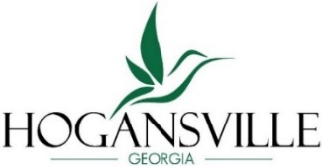
City of Hogansville
Downtown Development Authority
Meeting Agenda

Tuesday, April 28, 2026 at 6:00 pm
City Hall, 111 High Street, Hogansville GA 30230
Chair: Kent Berus 2028 Vice-Chair: Tamara Manross 2028 Treasurer: Keisha LeMay 2028 Board Member: Kandis Strickland 2026 Board Member: Jackson Fussell 2030 Board Member: Alexandrea Boyett 2030
;T

Call to Order
Agenda
- Approval of Agenda
- Approval of Minutes – March 24, 2026
Finance Report – Keisha LeMay
New Business
- Smokin Sounds Festival Discussion
- Finalization of committee nominations
- Property discussion
Committee Reports
- Organization – Engaging the community to plan and shape Main Street
- Design – Physical image of Main Street
- Economic Development – Strengthening businesses and revitalizing spaces
- Promotions- Marketing Main Street through ads, events, and activities
Upcoming Events

Next Meeting – May 26, 2026 – 6:00 pm

Adjourn

